# ADVANCED WEB APPLICATION DEVELOPMENT WEEK 11 ASSIGNMENT

# Discuss about different types of Data binding in Angular

Data binding is a technique, where the data stays in sync between the component and the view. Whenever the user updates the data in the view, Angular updates the component. When the component gets new data, the Angular updates the view.

There are many uses of data binding. You can show models to the user, dynamically Change element style, respond to user events, etc

Data Binding in Angular

The data binding in Angular can be broadly classified into two groups. Oneway binding or two-way binding

# One way binding

In one way binding data flows from one direction. Either from view to component or from component to view.

# From Component to View

To bind data from component to view, we make use of Interpolation & Property Binding.

# Interpolation

Interpolation allows us to include expressions as part of any string literal, which we use in our HTML. The angular evaluates the expressions into a string and replaces it in the original string and updates the view. You can use interpolation wherever you use a string literal in the view

The Angular uses the {{ }} (double curly braces) in the template to denote the interpolation. The syntax is as shown below

{{ templateExpression }}

The content inside the double braces is called Template Expression

The Angular first evaluates the Template Expression and converts it into a string. Then it replaces Template expression with the result in the original string in the HTML. Whenever the template expression changes, the Angular updates the original string again

# Property binding

The Property binding allows us to bind HTML element property to a

property in the component. Whenever the value of the component changes, the Angular updates the element property in the View. You can set the properties such as class, href, src, textContent, etc using property binding. You can also use it to set the properties of custom components or directives (properties decorated with @Input).

The Property Binding uses the following Syntax [binding-target]=”binding-source

# Attribute binding

Sometimes there is no HTML element property to bind to. The examples are aria (accessibility) Attributes & SVG. In such cases, you can make use of attribute binding The attribute syntax starts with attr followed by a dot and then the name of the attribute as shown below 1 2 3 X

# Two Way binding

Two-way binding means that changes made to our model in the component are propagated to the view and that any changes made in the view are immediately updated in the underlying component Two-way binding is useful in data entry forms. Whenever a user makes changes to a form field, we would like to update our model. Similarly, when we update the model with new data, we would like to update the view as well The two-way binding uses the special syntax known as a banana in a box [()]

# Discuss about CLI to create one application in ANGULAR.

Before starting with Angular, you need to set up your developer environment and install the required tools. Before going further install the following

* 1. Visual Studio Code (or any other editor of your choice)
  2. NPM Package Manager

You can read the instruction on how to install from the tutorial Installing and Setting Up an Angular Development Environment

# Installing Angular CLI

The first step is to install the Angular CLI. We use the npm install command.

1

2 npm install -g @angular/cli@latest 3

The above command installs the latest version of Angular CLI in your machine. Note that we have used the -g flag, (which stands for global) installs the Angular CLI system-wide so that you can use it in your all projects.

# Finding the Angular CLI Version

You can find out the Current Installed Angular CLI Version by Using the Command.

1

2 ng --version 3

The latest version as of writing this article is 8.3.19. The command above also gives the version of the node installed in your system. You can keep track of the latest Angular CLI release from this link

You can also read about it from how to check Angular CLI Version

# Creating a new Angular Application

The creation of your First Project Angular has become very simple using Angular CLI. All you need to run the command from the Prompt

1

2 ng new GettingStarted 3

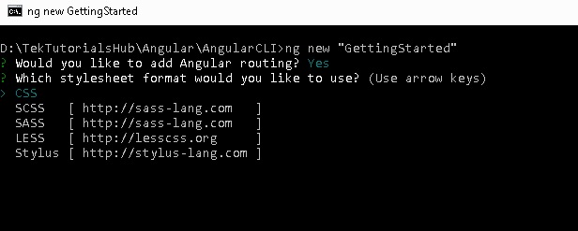

The above command will create a folder GettingStarted and copies all the required dependencies and configuration settings. The Angular CLI does the following

1. Creates a new directory GettingStarted is created
2. Sets up the folder structure for the application
3. Downloads and installs Angular libraries and any other dependencies
4. Installs and configures TypeScript
5. Installs and configures Karma & Protractor for testing

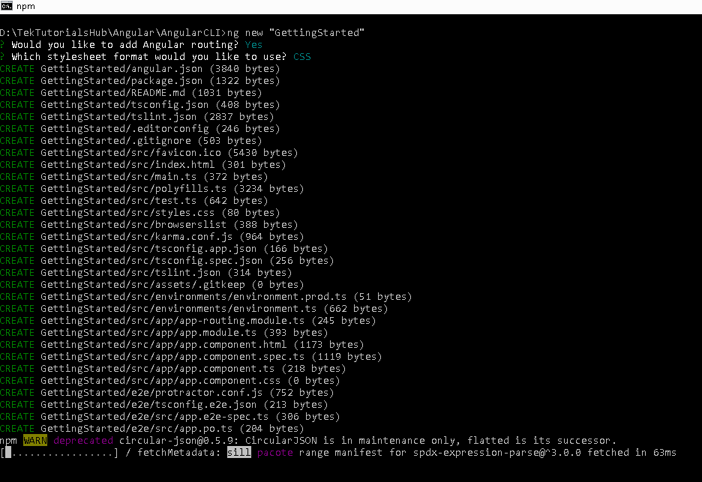

# Running your new Angular Project

To run your application all you need to do is type the following command

1

2 ng serve 3

The above command compiles the Angular application and invokes the Webpack development server. The server keeps a watch on our project folder. If you make any changes in the code, it compiles the project again.

You can also use npm start.

The Webpack Development server listens on HTTP Port 4200. Hence open the browser and type http://localhost:4200/ and you will see GettingStarted app is running displayed on the browser.